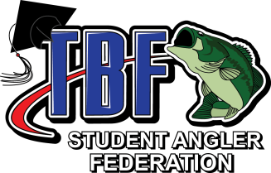
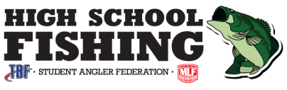
FACT SHEET – Kansas State Championship
Osage City, KS – Melvern Lake

Saturday, May 7, 2022 On-Site Tournament Director Hotline: 913-306-1110 TBF Senior Tournament Director Randy Sullivan: 580-716-4261

Check-in/Rules Meeting  Location:  Eisenhower East Ramp 29810 S. Fairlawn Rd. Osage City, KS 66523  Date:  Saturday, May 7, 2022 Check-in Times:  5:00a.m. – Check-in Opens  6:30 a.m. – Check-in Closes  6:30 a.m. – Mandatory rules briefing begins.  No teams are allowed to be on the water after the start of check-in, until the tournament begins. | Launch/Weigh-In  Launch Location: Eisenhower East Ramp 29810 S. Fairlawn Rd.  Osage City, KS 66523  Take-off will begin at 7:15 a.m. or first safe light thereafter.  Weigh-in begins: 2:30 p.m. | Required Items and Safety Equipment  It is the responsibility of each participant to have ALL required state and federal safety equipment on board as well as, ALL permits licenses, passes or stamps, Etc.  required.  At time of inspection each morning, be prepared to properly display 1 life jacket for each angler; 1 throwable PFD; and, demonstrate functioning kill switch.  Inspection will be held during lineup for takeoff. Live wells must be empty.  Anglers are required to have a valid KS 15 and older fishing license/ permit, if applicable by law. Bass Pass encouraged.
Fish Limits  Large, smallmouth, and spotted Bass 15" inches and over.  Anglers are allowed to weigh a limit of five (5) fish per team unless otherwise required by law or tournament officials.  Fish presented which fails to measure the official length limits shall accrue penalties at the rate of one (1) pound for each nonlegal fish plus loss of the fish. An 8-ounce deduction will be made for each fish presented that is determined to be non-releasable. | Tournament Director  Bill Horvath  913-306-1110 whorvath44@gmail.com  Host Hotel  Lebo Inn  2745 US 75  Lebo, KS 66856  620-256-6351 | Boundaries  Melvern Lake. Any waters within these boundaries posted "off limits" or "no fishing" by state or federal agencies will be off limits. Any live release areas established by the Tournament Director will be off limits. That as well as any additional off limits will be announced at the pre-tournament briefing. Only that water open to all public fishing will be considered tournament waters. Any waters closed to public fishing will be closed to this tournament's contestants. All local, state and federal regulations apply.
CLEAN DRAIN & DRY  YOUR BOATS BEFORE LEAVING HOME & AFTER EACH EVENT!  HELP STOP AQUATIC INVASIVE SPECIES.  Sign up for the FREE enewsletter at:  HighSchoolFishing.org | Each team must bring a completed & signed liability  waiver to the pre-tournament registration meeting.  Liability Release Form  Rules | Please read the Official 2021-2022 school year HSF State, Open & Challenges Rules carefully!  Daily Kansas State Park usage fees apply

Student Angler Federation – A Federation Of The Bass Federation (TBF), 5998 N. Pleasant View Rd., Ponca City, OK. 74601, Phone: (580)765-9031; Fax: (580)765-2890; Email: info@HighSchoolFishing.org www.HighSchoolFishing.org

